**LAPORAN PENGERJAAN UJI KOMPETENSI KEJURUAN**

**WEBSITE TO-DO LIST**



**Disusun oleh:**

|  |  |  |
| --- | --- | --- |
| KOMPETENSI KEAHLIAN | : | Rekayasa Perangkat Lunak |
| NAMA LENGKAP | : | Sa’diyyah Ajrin Az’zahra |
| KELAS | : | XII RPL 2 |
| NIS | : | 2223.10.415 |

**REKAYASA PERANGKAT LUNAK**

**SMK MAHARDHIKA BATUJAJAR**

**2025**

**LAPORAN PENGERJAAN UJI KOMPETENSI**

**KEJURUAN SMK MAHARDHIKA BATUJAJAR**

**TAHUN PELAJARAN 2024-2025**

|  |  |  |
| --- | --- | --- |
| KOMPETENSI KEAHLIAN | : | Rekayasa Perangkat Lunak |
| KELAS | : | XII RPL 2 |
| NAMA LENGKAP | : | Sa’diyyah Ajrin Az’zahra |
| NIS | : | 2223.10.415 |
|  |  |  |
| PAKET SOAL | : | To-Do List |
| JENIS APLIKASI | : | Web |
| ALOKASI WAKTU | : | 24 Jam |

1. **PENJADWALAN KEGIATAN**

|  |  |  |  |  |  |  |  |  |  |  |  |  |  |  |  |  |  |  |  |  |
| --- | --- | --- | --- | --- | --- | --- | --- | --- | --- | --- | --- | --- | --- | --- | --- | --- | --- | --- | --- | --- |
| Kegiatan | Minggu 1 | | | Minggu 2 | | | Minggu 3 | | | Minggu 4 | | | Minggu 5 | | | | Minggu 6 | | | |
| 1 | 2 | 3 | 4 | 5 | 6 | 7 | 8 | 9 | 10 | 11 | 12 | 13 | 14 | 15 | 16 | 17 | 18 | 19 | 20 |
| Analisis Soal |  |  |  |  |  |  |  |  |  |  |  |  |  |  |  |  |  |  |  |  |
| Perancangan Sistem |  |  |  |  |  |  |  |  |  |  |  |  |  |  |  |  |  |  |  |  |
| Perancangan DB |  |  |  |  |  |  |  |  |  |  |  |  |  |  |  |  |  |  |  |  |
| Perancangan UI/UX |  |  |  |  |  |  |  |  |  |  |  |  |  |  |  |  |  |  |  |  |
| Implementasi DB |  |  |  |  |  |  |  |  |  |  |  |  |  |  |  |  |  |  |  |  |
| Implementasi UI/UX |  |  |  |  |  |  |  |  |  |  |  |  |  |  |  |  |  |  |  |  |
| Implementasi Program |  |  |  |  |  |  |  |  |  |  |  |  |  |  |  |  |  |  |  |  |
| Finalisasi Program |  |  |  |  |  |  |  |  |  |  |  |  |  |  |  |  |  |  |  |  |
| Pengujian Program |  |  |  |  |  |  |  |  |  |  |  |  |  |  |  |  |  |  |  |  |
| Hosting + Github |  |  |  |  |  |  |  |  |  |  |  |  |  |  |  |  |  |  |  |  |
| Finalisasi Dokumentasi User Manual |  |  |  |  |  |  |  |  |  |  |  |  |  |  |  |  |  |  |  |  |
| Finalisasi Projek UKK |  |  |  |  |  |  |  |  |  |  |  |  |  |  |  |  |  |  |  |  |
| Dokumentasi |  |  |  |  |  |  |  |  |  |  |  |  |  |  |  |  |  |  |  |  |

1. **PERSIAPAN PERANGKAT KERAS**

|  |  |  |
| --- | --- | --- |
| Laptop ASUS TUF dengan Spesifikasi berikut | : | Windows 11 Home Single Languange 64-bit (10.0, Build 22631) Intel(R) Core(TM) i5-10300H CPU @ 2.50GHz (8 CPUs), ~2.5Ghz |
| Smart Phone | : | Android |
| Koneksi Internet | : |  |

1. **PERSIAPAN PERANGKAT LUNAK**

* Visual Studio Code
* Laragon
* Chrome
* Astah
* Balsamiq
* Microsoft Word

1. **PERANCANGAN ALGORITMA APLIKASI**

Registrasi

Login

Tambah Data

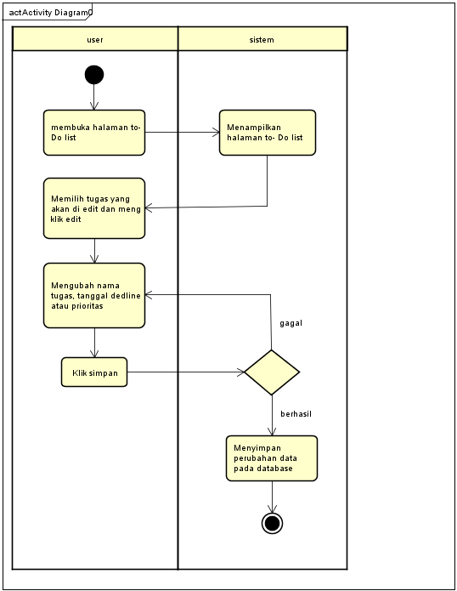

Edit Data

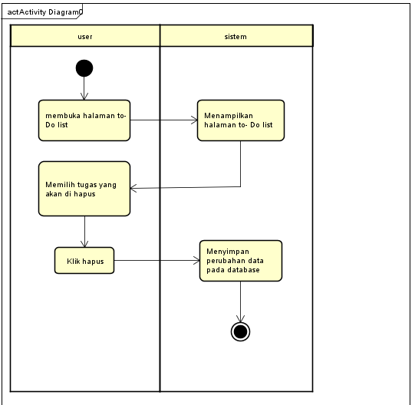

Hapus Data

1. **PERANCANGAN DESAIN BASIS DATA**

1. **DUMMY DATA**

*Buat data dummy/bohongan yang dipersiapkan untuk nanti dimasukkan*

1. Users

|  |  |  |  |
| --- | --- | --- | --- |
| userid | usernamae | password | created_at |
| 1 | wisnu | 2y$10$NzQzSpi6BzM9vI2IfGUzyOdQj8sc2Ya4g68hanol2lJ | 2025-04-08 06:29:13 |

1. Tasks

|  |  |  |  |  |
| --- | --- | --- | --- | --- |
| taskid | userid | tasklabel | taskstatus | taskdate |
| 2 | 2 | sekolah | open | 2025-04-10 |

1. Subtask

|  |  |  |  |  |  |  |
| --- | --- | --- | --- | --- | --- | --- |
| subtask  -id | taskid | subtask_label | subtask_date | subtask_priority | subtask_status | created_at |
| 1 | 2 | makan | 2025-04-03 | medium | open | 2025-04-08 11:49:04 |

1. **PEMBUATAN BASIS DATA {MySQL Code)**
2. Tabel Users

1. Tabel Tasks

1. Tabel Subtask

1. **PERANCANGAN TAMPILAN ANTARMUKA (UI) WEB**

* **Use Case**

* **Scenario Berjalan**

|  |  |  |
| --- | --- | --- |
| Nama | : | Register |
| Id | : | US -1 |
| Deskripsi | : | User mendaftarkan akun baru di sistem |
| Aktor | : | User dan Sistem |

|  |  |
| --- | --- |
| Scenario Utama  Aksi User | Reaksi Sistem |
| 1. Membuka halaman registrasi. |  |
|  | 1. Menampilkan tampilan register. |
| 1. Mengisi username, dan password. |  |
|  | 1. Memvalidasi data yang dimasukkan oleh user. |
|  | 1. Jika data valid, sistem menyimpan informasi pengguna ke dalam database. |
|  | 1. Menampilkan pesan sukses register kepada user. |
| Scenario Alternatif |  |
|  | 1. Jika data tidak valid, Sistem meminta input ulang. |

|  |  |  |
| --- | --- | --- |
| Nama | : | Login |
| Id | : | US- 2 |
| Deskripsi | : | User masuk ke sistem dengan username dan password |
| Aktor | : | User |

|  |  |
| --- | --- |
| Scenario Utama  Aksi User | Reaksi Sistem |
| 1. Membuka halaman login. |  |
|  | 1. Menampilkan halaman login. |
| 1. Memasukkan username dan password. |  |
|  | 1. Memvalidasi data login. |
|  | 1. Memberikan akses ke akun user. |
| Scenario Alternatif |  |
|  | 1. Jika login gagal, sistem menampilkan pesan error dan meminta input ulang. |

|  |  |  |
| --- | --- | --- |
| Nama | : | Tambah Tugas |
| Id | : | US- 3 |
| Deskripsi | : | User memasukkan data tugas baru ke dalam sistem |
| Aktor | : | User |

|  |  |
| --- | --- |
| Scenario Utama  Aksi User | Reaksi Sistem |
| Membuka halaman utama To-Do List. |  |
|  | 1. Menampilkan halaman utama To-Do List. |
| 1. Mengisi nama tugas, dan tanggal deadline. |  |
|  | 1. Memvalidasi data tugas. |
|  | 1. Menyimpan tugas dan menampilkan daftar tugas yang diperbaharui. |
| Sistem Alternatif |  |
|  | 1. Jika data tidak valid, sistem meminta input ulang. |

|  |  |  |
| --- | --- | --- |
| Nama | : | Edit Tugas |
| Id | : | US- 4 |
| Deskripsi | : | User memasukkan data subtask baru ke dalam sistem |
| Aktor | : | User |

|  |  |
| --- | --- |
| Scenario Utama  Aksi User | Reaksi Sistem |
| 1. Memilih task yang akan di edit lalu klik edit. |  |
|  | 1. Menampilkan halaman edit. |
| 1. Mengubah nama task dan tanggal deadline lalu klik edit. |  |
|  | 1. Menampilkan task yang sudah ter update. |
| Sistem Alternatif |  |
|  |  |

1. **MOCK UP**
2. Register

1. Login

1. Tampilan Utama To-Do List

1. Edit TugasA screenshot of a computer

   AI-generated content may be incorrect.
2. Edit Subtasks

1. **PENGUJIAN WEB**
2. Register

|  |  |  |  |  |  |  |
| --- | --- | --- | --- | --- | --- | --- |
| **No** | **Module Name** | **Pre**  **Condition** | **Test**  **Case** | **Test Scenario** | **Expected Result** | **Actual Result** |
| 1. | Register | Pengguna belum memiliki akun | Isi username, password klik Register | Buka halaman register, input data, klik tombol register | Akun berhasil dibuat dan diarahkan langsung ke halaman login |  |
| 2. | Register | Username sudah terdaftar | Menggunakan username dan password yang sudah ada | Isi from dengan data yang sudah ada | Muncul pesan error |  |

1. Login

|  |  |  |  |  |  |  |
| --- | --- | --- | --- | --- | --- | --- |
| **No** | **Module Name** | **Pre**  **Condition** | **Test**  **Case** | **Test Scenario** | **Expected Result** | **Actual Result** |
| 1. | Login | Akun pengguna sudah terdaftar | Isi username, password klik login | Buka halaman login, input data, klik tombol login | Pengguna berhasil masuk kedalam halaman utama |  |
| 2. | Login | Username belum terdaftar | Menggunakan username dan password yang belum terdaftar | Isi from dengan data yang belum terdaftar | Muncul pesan error |  |

1. Tambah Tugas

|  |  |  |  |  |  |  |
| --- | --- | --- | --- | --- | --- | --- |
| **No** | **Module Name** | **Pre**  **Condition** | **Test**  **Case** | **Test Scenario** | **Expected Result** | **Actual Result** |
| 1. | Tambah tugas | Menambahkan tugas yang belum ada di database | Isi nama tugas, tanggal deadline klik tambah | Buka halaman to_ Do list, input data, klik tombol to- D0 list | Pengguna berhasil menambahkan nama tugas baru |  |
| 2. | Tambah tugas | Mengisi from tambah tugas tidak lengkap | Mengisi from dengan membiarkan salah satu nya kosong | Mengisi from dengan membiarkan salah satu item koosng | Muncul pesan error |  |

1. Edit Tugas

|  |  |  |  |  |  |  |
| --- | --- | --- | --- | --- | --- | --- |
| **No** | **Module Name** | **Pre**  **Condition** | **Test**  **Case** | **Test Scenario** | **Expected Result** | **Actual Result** |
| 1. | Edit tugas | Mengedit tugas yang sudah ada | Isi nama tugas, tanggal deadline klik tambah | Buka halaman to_ Do list, input data, klik tombol to- D0 list | Pengguna berhasil menambahkan nama tugas baru |  |
|  |  |  |  |  |  |  |

1. **Revisi**
2. **Penentuan Domain dan Hosting**

Hosting : https://rumahweb.com

Domain : https://idcloudhost.com

1. **Upload Web ke Hosting**

https://todoapps.web.id

1. **Upload Web ke Github**

https://github.com/sadiyyahajrinazzahra/todolistt